Curriculum Vitae 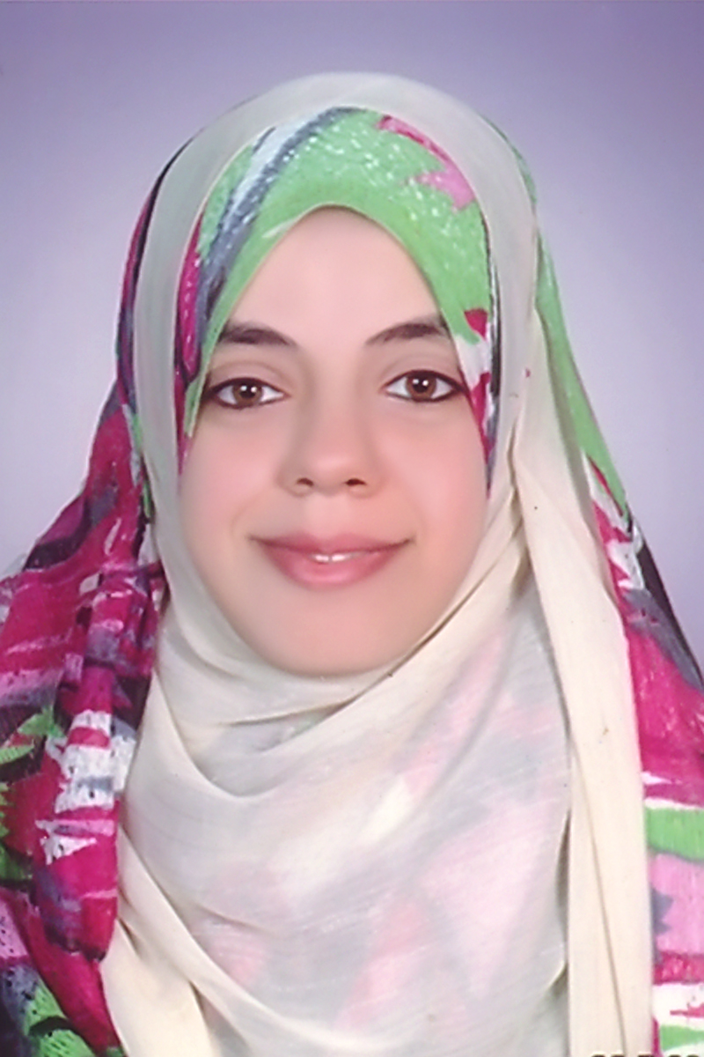

PERSONAL
- Name: Walaa Mohamed Sayed Gomaa
- Date of Birth: Dec. 3, 1985
- Marital Status: Married with one son
- Languages: Arabic (native),
English (TOEFL iBT)
Germany (Eins)
- Computer: International Computer Driving License (ICDL)
- Nationality: Egyptian

ADDRESS
- Department of Animal Nutrition and Clinical Nutrition, Faculty of Veterinary Medicine, Assiut University, Assiut, Egypt
- Phone: 00201061991650
- E-mail: lola2008_vet@yahoo.com

EDUCATION
- 1991-1996: Primary school
- 1996-1999: Prep school
- 1999-2002: Secondary school
- 2002-2007: Faculty of Veterinary Medicine, Assiut University, Egypt.
- 2007: Granted the Degree of Bachelor of Veterinary Medical Sciences (Excellent with Honor Grade)
- 2008-2009: Advanced postgraduate courses in Animal Nutrition and Clinical Nutrition in partial fulfillment of the requirements of the master degree:
  - Feed Analysis and Ration Formulation: Excellent
  - Rabbit Nutrition: Excellent
  - Biostatistics: Excellent
  - Poultry and Rabbit Diseases: Very Good
  - Poultry Nutrition: Good
  - Basic Animal Nutrition and Farm animal Nutrition: Passed
- September, 2012: Master Degree, M.V.Sc., in Animal Nutrition and Clinical Nutrition from Assiut University, Egypt.
- 2012-2013: Advanced Ph.D courses in Animal Nutrition and Clinical Nutrition in partial fulfillment of the requirements of the Ph.D degree:
  - Advanced Poultry Nutrition: Excellent
  - Wild Life Nutrition: Excellent
  - Clinical Animal Nutrition: Excellent
  - Advanced Feed Analysis: Excellent

Supervisors of Master Thesis:
Prof. Dr. Abdel-Sattar M. Abd-Ellah
Prof. Dr. Abdel Baset Nasr Sayed
Prof. Dr. Gamal M. Mohani Mosaad
Professors of Animal Nutrition and Clinical Nutrition, Department of Animal Nutrition and Clinical Nutrition, Faculty of Veterinary Medicine, Assiut University, Assiut, Egypt.

Title of Master Thesis:
"Effect of Dietary Energy and Protein Levels on Performance of Rabbits in Hot Climate"

Supervisors of Ph. D Thesis:
- Prof. Dr. Abdel-Sattar M. Abd-Ellah
- Prof. Dr. Gamal M. Mohani Mosaad
Professors of Animal Nutrition and Clinical Nutrition, Department of Animal Nutrition and Clinical Nutrition, Faculty of Veterinary Medicine, Assiut University, Assiut, Egypt.

POSITIONS
- 2007-2012: Demonstrator of Animal Nutrition and Clinical Nutrition, Department of Animal Nutrition and Clinical Nutrition, Faculty of Veterinary Medicine, Assiut University, Assiut, Egypt.
- 2012 till now: Assistant lecturer of Animal Nutrition and Clinical Nutrition, Department of Animal Nutrition and Clinical Nutrition, Faculty of Veterinary Medicine, Assiut University, Assiut, Egypt

FIELD OF EXPERIENCE
- Animal Nutrition & Clinical Nutrition

CONTRIBUTION TO CONFERENCE
- 15th Scientific Congress, 25-27 Nov. 2012 Faculty of Veterinary Medicine, Assiut University, Assiut, Egypt
REFERENCES
- Prof. Dr. Abdel-Sattar M. Abd-Ellah Professor of Animal Nutrition and Clinical Nutrition, Department of Animal Nutrition and Clinical Nutrition, Faculty of Veterinary Medicine, Assiut University, Assiut, Egypt.
- Prof. Dr. Gamal M. Mohani Mosaad Professor and Head of Department of Animal Nutrition and Clinical Nutrition, Faculty of Veterinary Medicine, Assiut University, Assiut, Egypt.
- Prof. Dr. Abdel Baset Nasr Sayed Professor of Animal Nutrition and Clinical Nutrition, Department of Animal Nutrition and Clinical Nutrition, Faculty of Veterinary Medicine, Assiut University, Assiut, Egypt.
- Prof. Dr. Hasan Abbas Abdel-Raheem Professor of Animal Nutrition and Clinical Nutrition, Department of Animal Nutrition and Clinical Nutrition, Faculty of Veterinary Medicine, Assiut University, Assiut, Egypt.
- Dr. Sherief Mohammed Abdel-Raheem Lecturer of Animal Nutrition and Clinical Nutrition, Department of Animal Nutrition and Clinical Nutrition, Faculty of Veterinary Medicine, Assiut University, Assiut, Egypt.

